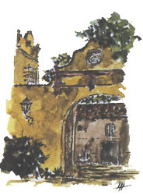
Instituto Valenciano de Microbiología
Masía El Romeral
Ctra. Bétera – San Antonio de Benagéber, Km 0,3
46117 Bétera (Valencia)
Tel. 96 169 17 02
e-mail: ivami@ivami.com
www.ivami.com
CIF B-96337217
Laboratory authorised by the European Union for rabies serology test to control the efficacy of antirabies vaccines

Quantification of anti-rabies antibodies in vaccinated animals
Information summary
Test information:

The test is performed using the method recommended by the Reference Laboratory of the European Union in Nancy-ANSES- (France) (Laboratoire de la Rage et de la Faune Sauvage de Nancy, France). The test quantify the anti-rabies antibodies by a neutralization viral assay (FAVN: Fluorescent Antibody Virus Neutralization), using a quantified suspension of rabies virus strain CVS-11.

This procedure is complex and costly because: 1) it uses a quantified (titrated) rabies virus suspension in the test to face against the serum from the animal; 2) it uses BHK-21 cells in culture, to exhibit the virus neutralization by the antibodies in case they are present in the tested serum; 3) It uses the immunofluorescence using anti-rabies fluorescent labelled antibodies to show the replication (viability) or non-replication (non-viability) of the virus in the inoculated cell cultures; 4) The serum should be assayed at several dilutions to quantify the amount of antibodies present, and all should be done quadruplicated; and 5) It should be done in comparison with an international reference serum that contains a known amount of anti-rabies antibodies, to be able to report the results in International Units (IU/ml). To consider that the animal is protected against rabies, the tested serum should show an antibody titre equal or higher than 0,5 IU/mL.

Recommended sample: serum from the animal separated from the whole blood (1 to 2 mL), taken in a dry tube or in a Vacutainer tube with serum isolator. As an alternative, if the sample of blood arrives to our laboratory the following day, it is possible to send the whole blood sample (5 to 10 mL), and we will separate the serum in our laboratory. Sample of blood from the animal should be obtained at least 30 days, after completion of the vaccine schedule, to allow the generation of antibodies induced by the vaccine. When animal comes from any country outside the European Community, the blood sample must be taken at least 3 months before travelling, by a registered veterinarian.

Results reports delay: 7 to 9 working days from the sample reception date.
Test cost: 121.-€ (taxes included).
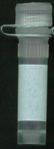
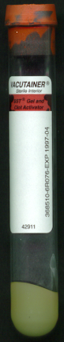
Shipment of samples: for shipping of samples of separated serum, or whole blood, our laboratory offers, without added cost, a courier service in Spain (not for foreign countries, Canary or Baleares islands) that we can send after calling to phone 96-169 1702. The serum, or the blood sample, should be shipped inside a plastic container (see picture), if possible, inside a biological safety container, and this inside an isotermic box (white cork), and besides, if possible, under refrigeration using a frozen pack. Introduce the order form provided with all data of the sample. Do not send the shipment on Fridays because we are closed on Saturday and shipment cannot be delivered until Monday.
Isotermic box (white cork) with the frozen pack, and the biological safety, or a similar container, with the tube including the sample.
Labelled tube with the sample
Security safety container, or similar, holding the tube with the sample

